Okanagan Heritage Museum
Social & Business Rentals
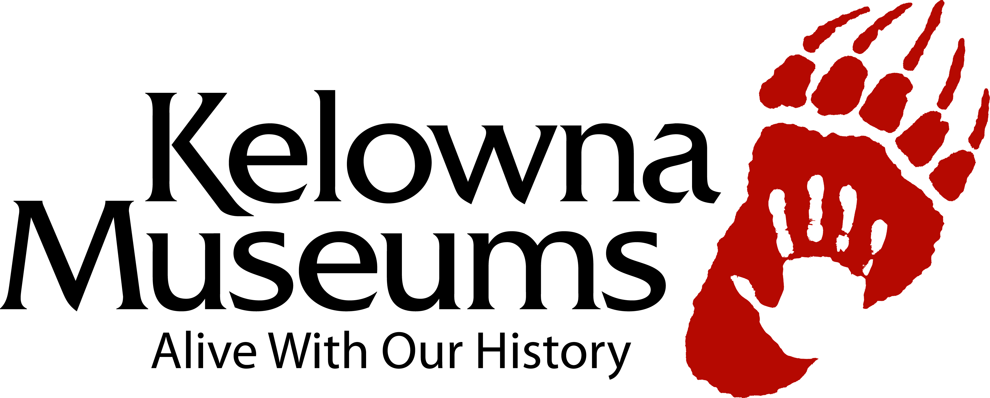
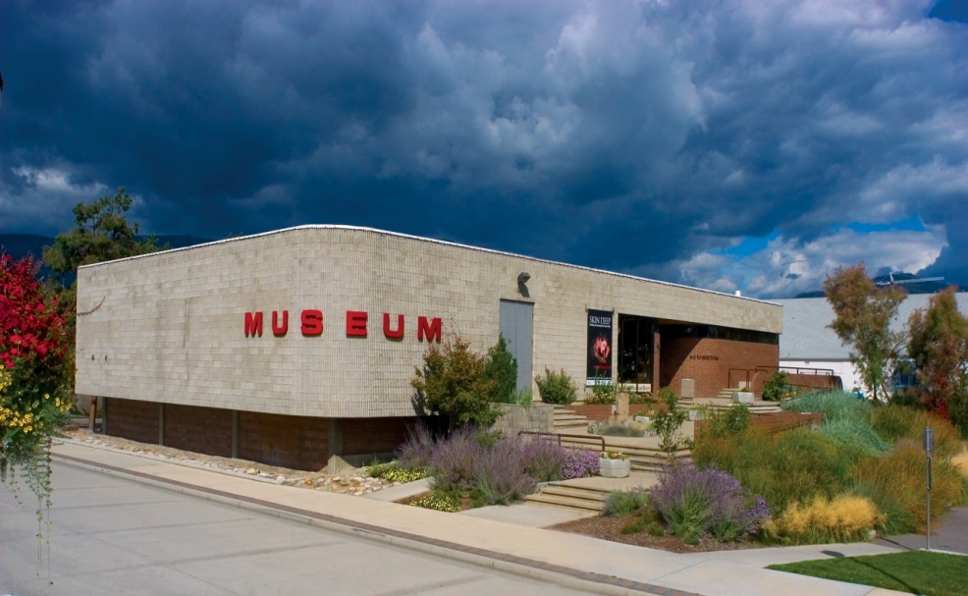

Okanagan Heritage Museum Facility Rental

When thinking of your next meeting, client appreciation, lecture, or wine & cheese social, think no further than the Okanagan Heritage Museum. We would love to make your next event an historic occasion.

The Okanagan Heritage Museum features 1200 sq feet of open space surrounded by local and regional exhibitions to enhance and enliven your next event. This space is perfect for an intimate dinner or social gathering. Enjoy artefacts such as a Pioneer Chinese Grocery Store, a Trading Post from the 1860s, and our Natural History Gallery.

Why not consider further enhancing the ambiance with special entertainment, creative table settings, diverse food, appetizers, and wine selected from our BC Wine Museum & VQA Wine Shop.

Our exciting exhibits will give your event a unique backdrop, making your next occasion one-of-a-kind. Contact Nikki Valletta to get more details on what is available at 778.478.0325 or bookings@kelownamuseums.ca.

Sincerely,

Nikki Valletta
Facilities Rental Coordinator
Kelowna Museums

Table of Contents

Okanagan Heritage Museum Facility Rental 2
Okanagan Heritage Museum Rental Information 4
Maximum Capacity for Main Floor 4
Venue Rentals Include 4
Additional Services & Rentals Available 4
Conditions of Use 5
Use 5
Insurance 5
Payment Policies 5
Cancellation Policy 5
Hours of Operation 6
Parking & Loading Dock 6
Licenses 6
Renter’s Responsibilities 6
Alcohol & Food Service 6
Security 7
Event Set-Up & Tear Down 7
Miscellaneous 7
Frequently Asked Questions 8
Okanagan Heritage Museum Dimensions 10
Event Checklist 11
Preferred Service Providers 12
Caterers 12
Bar Services 12
Event Rentals 12
Event Planning 12
Facility Photos 13

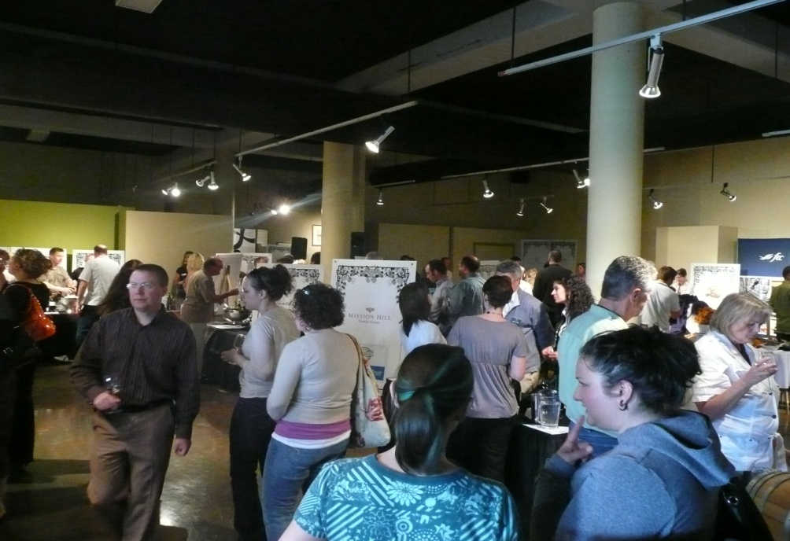

A. Okanagan Heritage Museum Rental Information

The Heritage Museum has 1200 square feet of open space available for rent for your event. We are happy to assist you in making this event an historical one.

Maximum Capacity for Main Floor
These are listed according to fire code regulations.
- Stand-up: 150
- Banquet style: 80

Venue Rentals Include
When renting the facility you have access to various services and amenities in the building:
- Consultation for facility usage
- 50 folding chairs
- 6 rectangular tables (6’ long)
- Access to the downstairs prep kitchen starting at 3:00 p.m.
- Access to the Gallery space for set up starting at 4:00 p.m.
- Washroom facilities (wheel chair accessible)

Additional Services & Rentals Available

These services are available during your event for an extra fee. Details and rates are listed in our rates package.
- Tutored wine tastings
- Guided Museum tours
- Spousal Tours
- Audio Visual Equipment

B. Conditions of Use (please refer to your contract for full terms and conditions)

Use
- The Renter agrees that no other event or purpose shall be substituted for the stated purpose, and this will be the only use of the premises, and this use will be in lawful, proper manner and will not breach any local by-laws. Signature, deposit and proof of insurance must be provided prior to use of rental space.
- The facility must be left in the same condition as you found it.

Insurance
- The Renter shall procure and maintain, at its own expense, and cost, a comprehensive general liability insurance policy for an inclusive amount of no less than two million dollars for the term of the rental agreement.
- The Renter must provide a Certificate of Insurance form as evidence of their insurance requirement and the Kelowna Museums Society and the City of Kelowna have been named thereon as Additional Insured. The Certificate must be forwarded to the Rental Coordinator no later than 14 days in advance of the rental date.

Payment Policies
- In order to reserve space for your event, a rental contract must be signed and a deposit of 50% of the rental fee must be submitted. The space will not be reserved until the deposit is paid in full.
- All payments are to be made to the Kelowna Museums Society.
- The rental fee must be paid in full, no later than 14 days in advance of the rental date.
- You must sign a valid Visa or MasterCard imprint which will be taken at the time of booking to cover damages that may occur during the rental.
- Before and after the event, the Rental Coordinator will inspect the facility with you. If conditions are to be found satisfactory after the event, no invoice will be presented.
- Final charges may vary depending on the Licensee’s actual use of the space. Settlements will be within 10 business days after the event.
- Outstanding accounts over 15 days overdue will be subject to a 1.5% interest per month to 18% per year.

Cancellation Policy
- Cancellations must be made at least 14 days prior to the event. If this deadline is not met, the Renter will forfeit their rental deposit.
- If cancellation is received more than 14 days prior to the facility usage, the Renter will be reimbursed all fees with the exception of a $50 administration fee.

Hours of Operation
- The Okanagan Heritage Museum is open to the public from 10am to 5pm. Renters get access to the building from 5pm to 10pm or 9am to 10pm for events. Every hour used beyond your rental agreement you will be charged as per fee structure.
- Speak to the Rental Coordinator ahead of time if the above times do not suit your event.

Parking & Loading Dock
- The Okanagan Heritage Museum does not provide parking for events.
- Parking hours and fees around the museum are posted and enforced by the City of Kelowna.

Licenses
- If alcohol is going to be served at the event, a Special Occasions License must be obtained by the Renter from the British Columbia Liquor Board at least 14 days prior to the event.
Note: the person applying for the Special Occasions License must possess a Serving It Right certificate and must be present at the event.
- The Special Occasions License is to be displayed at all times.
- All alcohol must be served by a licensed Serving It Right bartender from our Preferred Service Provider list. If they are not included on that list, they will be required to complete a tour and orientation of the Okanagan Heritage Museum at least 5 business days prior to the event.
- The Renter is fully responsible for obtaining and ensuring that all alcohol regulations are met.

Renter’s Responsibilities
- The Renter is responsible for and liable for the conduct of all of their guests and sub-contractors.
- The number of people in the building must not exceed posted capacity.
- The Kelowna Museum Society is not liable for any loss of or damages to any goods belonging to the Renter, the Renter’s guests, and the Renter’s subcontractors.

Alcohol & Food Service
- If catering is required, the Renter shall advise the Rental Coordinator of all catering arrangements, including the name of the caterer, time of arrival, etc.
- The Renter is to organize all food and beverage services as needed and is responsible for their attendant costs (including cutlery, plates, napkins, and any other required items).
- Propane tanks are strictly prohibited.

Security
- The Kelowna Museums Society will determine how much security is needed and will provide security for the event.

Event Set-Up & Tear Down
- Seating plans are to be sent to the Rental Coordinator at least 5 business days prior to your event.
- Tables and chairs are to be set up and taken down by KMS staff only to ensure the integrity of the building.

Miscellaneous
- All decorations and items (i.e. catering and alcohol supplies, extra tables and chairs, music and sound equipment, garbage, etc) must be dismantled and taken away from the premises by the end of the allotted rental time.
- KMS staff are available for consultation but are unable to assist the Renter with operation of the event itself. Please refer to the Event Staff Checklist for guidelines on staffing your event.

C. Frequently Asked Questions

What is needed to reserve my date?
You will need to have a signed Facility Rental Agreement, credit card imprint, and 50% rental deposit completed with the Rental Coordinator.

Can decorations be used in the Laurel?
Yes, the tables and chairs can be decorated and you may use free standing decorations. Candles may be used at the tables providing they are unscented and the flames have been enclosed in votives.

Can we have music?
Yes, live acoustic music is preferred and you may also use a DJ.
NOTE: A reasonable volume must be maintained at all times as the Laurel Packinghouse houses sensitive objects.

Is alcohol permitted?
Only wine and beer are permitted. Wine must be purchased from the on-site BC Wine Museum & VQA Wine Shop.

Can we bring in our own caterer and bartender?
Please see our list of Preferred Service Providers. Any other licensed bartenders must be licensed, approved by the Rental Coordinator, and have completed a tour and orientation of the Laurel Packinghouse.

Will the museums still be open to the public if I have rented the Laurel Packinghouse for that day?
Yes, the BC Orchard Industry Museum and the BC Wine Museum & Wine Shop will be open to the public during its regularly scheduled hours.

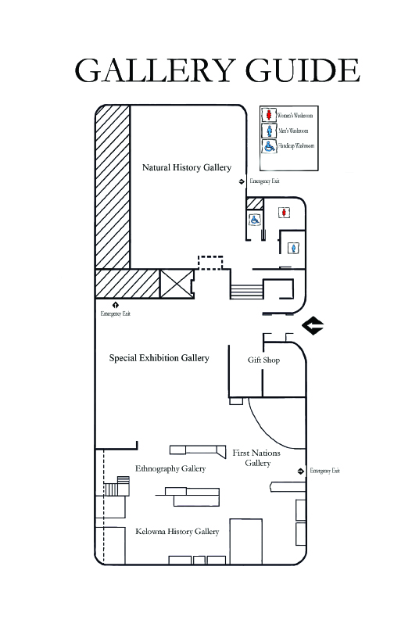
D. Okanagan Heritage Museum Dimensions

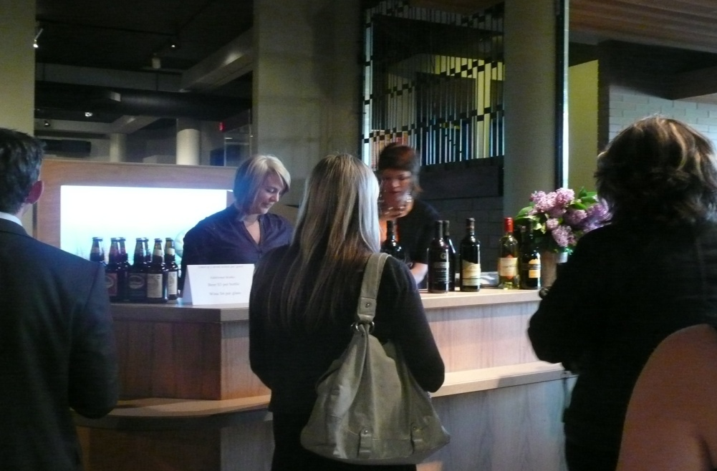
E. Event Checklist

Please consider these guidelines to help organize your event:
- Door attendant- the Laurel Packinghouse is usually closed to the public at 6:00 p.m. on weekdays and at 5:00 p.m. on weekends. You may find it necessary to have a door attendant or greeter to keep uninvited individuals out of your private event.
Recommended number of Door Attendants: 1

- Bartender- all alcohol must be served by licensed Serving It Right bartenders.
Recommended number of Bartenders: 1 per 75 - 100 people

- Caterer & Servers – all food must be prepared according to legal food safety requirements. It is the responsibility of the renter to ensure the catering company you use provided you with the proper number of staff needed to care for your guests in an efficient manner.
List of our preferred caterers to follow.
NOTE: The Laurel Packinghouse is an important Heritage Site that has some specific requirements for its care. Accordingly caterers and equipment service providers who are not on this list are required to attend a site visit and tour and must agree to care for and treat the building in its important heritage context.

- Set up & Clean-up Crew- consider your set up and clean up requirements (i.e. setting up and taking down decorations, food, drink, etc). Also consider your needs during the event (i.e. collecting dirty glasses and dishes, monitoring garbage receptacles, etc). All take down and clean up must be completed by the end of your rental time.
Recommended number for Set up and Clean up: 4-5

- Registration- depending on the type of your event, you may need a registration table with someone to collect tickets, register guests, hand out information, etc.
Recommended number for Registration: 1-2

- Audio-Visual Needs – consider what types of equipment you will need for your event ie. flip charts, markers, video projector, screen, CD player, lectern w/ microphone, enforcer speaker systems, cable outlet, high speed internet wired, and whiteboards.
List of equipment available for rent on rates package.

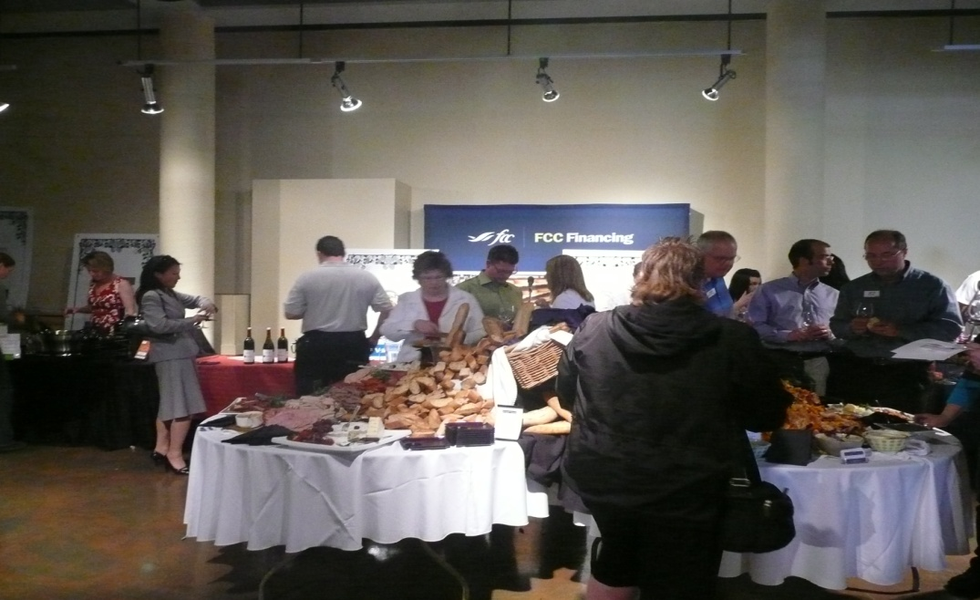
F. Preferred Service Providers

Below are caterers, bartenders, event planners, and other Service Providers who we recommend and who are familiar with the Laurel Packinghouse.*

NOTE: KMS receives no fees from any of the Preferred Service Providers and in many ways considers them partners in the care and presentation of the Laurel Packinghouse as a vital part of our Okanagan Heritage.

Caterers
Art of Fine Catering, 250-763-8051, www.theartoffinecatering.com
Bohemian Bagel Café, 250-862-3517, www.bohemiancater.com
Bread Company, 250-762-3336, www.thebreadcompany.ca
De Montreuil Home, Office & Event Catering, 250-859-4204, grantdemontreuil@gmail.com
Deli City Café/ Bunches Bistro, 250-860-8880, www.delicitybunches.com
Divine Feast, 250-317-5377, www.divinefeast.ca
Okanagan’s Finest Foods – 250-317-2055, www.okanagansfinest.com
Okanagan Street Food, 250-469-1915, www.okanaganstreetfood.com
Truffles Chocolate Café, 250-448-8783, www.truffleschocolatecafe.com

Bar Services
Black Tie Bartending, 250-317-2341, blacktiebartending@hotmail.com

Event Rentals
All Occasions Party Rentals, 250-763-8687, www.alloccasionspartyrent.com
SW Audio Visual, 250-868-3333, www.sw-online.com
TTM Events, 250-868-8255, www.ttmevents.com

Event Planning
A Stylish Affair, 778-755-5585, www.astylishaffair.ca
Impact Events & Project Management, 250-469-1958, www.impacteventsandprojects.com
Synergy Events, 250-763-9009, www.synergyevents.ca
Total Events, 250-769-9248, www.totalevents.ca

*If you choose to use a Service Provider who is not on this list, they must first complete a tour and orientation of the facility at least 5 business days prior your event.

All sub-contractors and service providers are the responsibility of the Renter and must sign the Sub-Contractor Agreement portion of the contract.

